**Chemical Engineering Lab- II**

**Experiment-4**

**Group-5**

**Madhav Rathi (2018A1PS0723P)**

Himanshu Chaturvedi (2018A1PS0031P)

Himanshu Singh (2018A1PS0025P)

Gaurav Bellal Natesh (2018A1PS0027P)

Avish Goel (2018A1PS0734P)

**BITS Pilani**

**Experiment: 4-a)**

**Basket Centrifuge**

1. ***Aim:***

To study the characteristics of Basket centrifuge.

1. ***Objective:***

* To determine % recovery of water and % water retained by the cake for 5 wt % and 10 wt% slurry at different speeds of rotation of basket.

1. ***Observations & Calculations:***

|  |  | **Volume of water = 4.5 lit.** | |  |  |  |
| --- | --- | --- | --- | --- | --- | --- |
|  |  | **CaCo3 = 500g** | |  |  |  |
|  |  |  | |  | **Empty wt. of pan = 63g** | |
| **Set No** | **Variac reading (rpm)** | **Feed concentration (%)** | **Volume of the filtrate collected (lit.)** | **Time of filtration (sec)** | **Weight (g)** | |
| **Wet Cake** | **Dry Cake** |
| 1 | 50 | 10 | 4 | 81 | 69 | 66 |
| 2 | 60 | 10 | 4.2 | 53 | 76 | 72 |
| 3 | 70 | 10 | 4.3 | 45 | 83 | 79 |

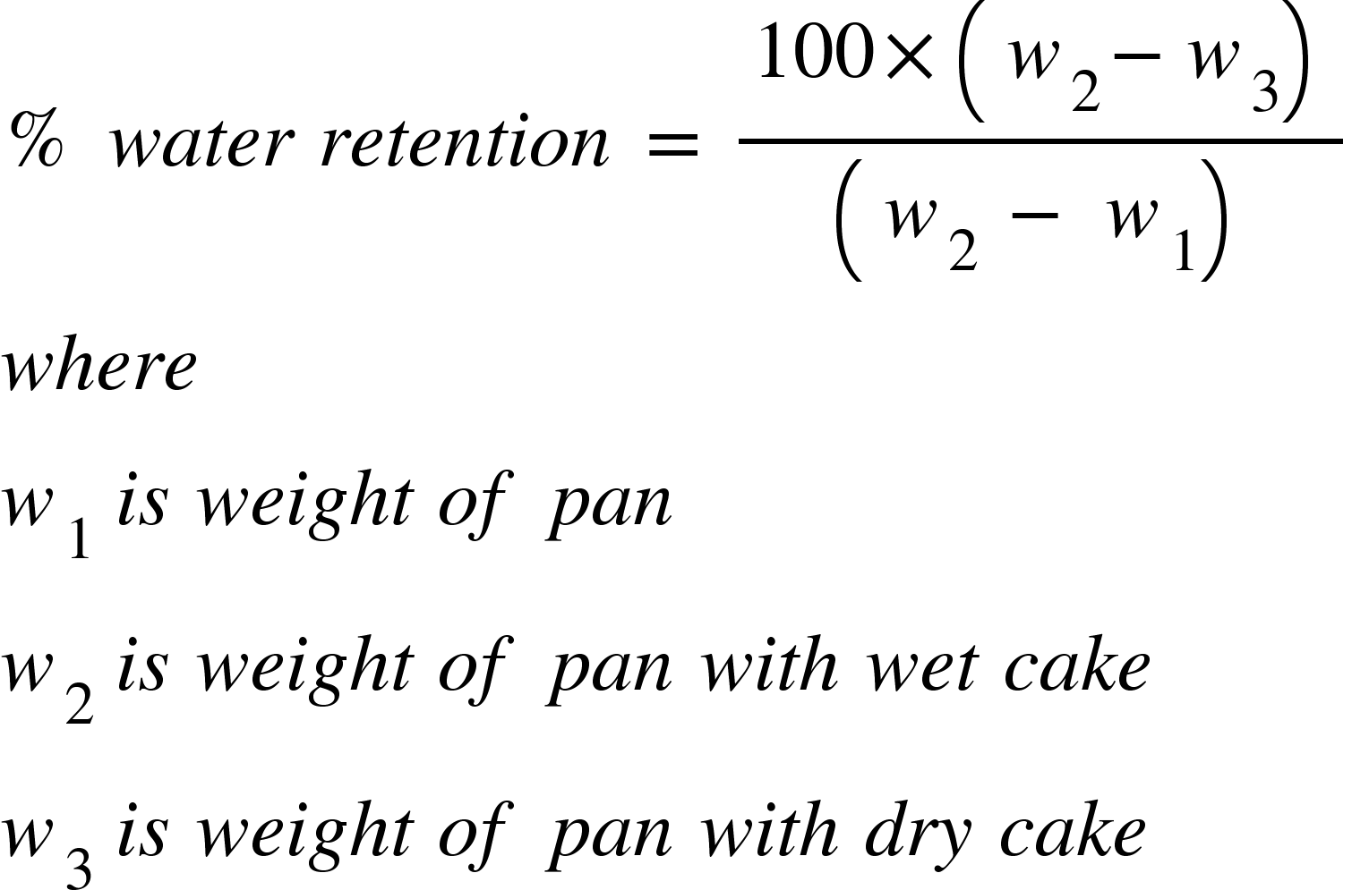

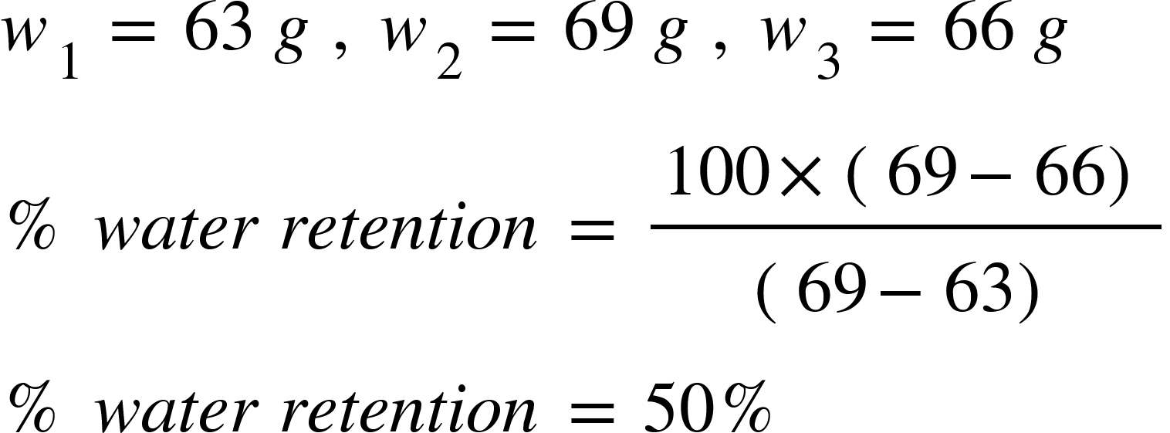

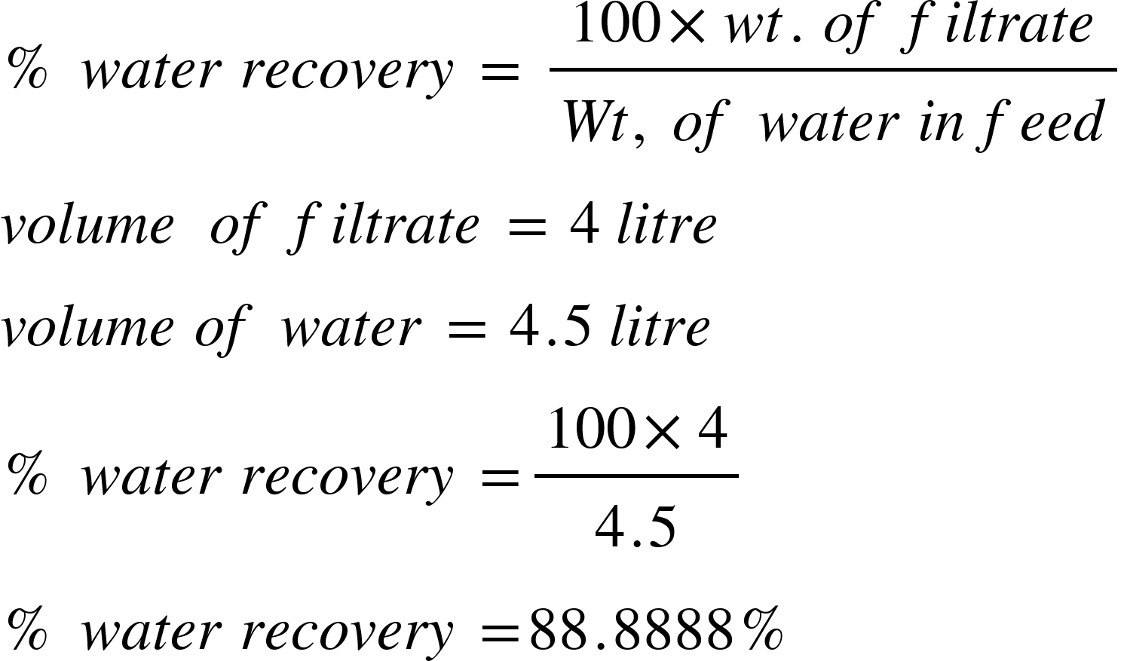

1. ***Results and Discussions:***

| **S.No.** | **Volume of filtrate(litre)** | **Wt. of wet cake(g)** | **Wt of dry cake(g)** | **% water retention** | **% water recovery** | **% water retention using water recovery** |
| --- | --- | --- | --- | --- | --- | --- |
| **1.** | 4 | 69 | 66 | 50 | 88.8888 | 11.11111111 |
| **2.** | 4.2 | 76 | 72 | 30.76923 | 93.3333 | 6.666666667 |
| ***3.*** | 4.3 | 83 | 79 | 20 | 95.5555 | 4.444444444 |

From the above table it is evident that the percentage retention of water using the mass of wet cake and dry cake is greater than the percentage retention of water using water recovery.

This might be due to the fact that the retention calculated using the mass of wet and dry cake requires the use of a heater where the water is removed from the wet cake. The heater is limited by its efficiency and might not be able to completely remove the water from the wet cake. Thus even in the dry cake some moisture might be trapped. This led to increased retention value.

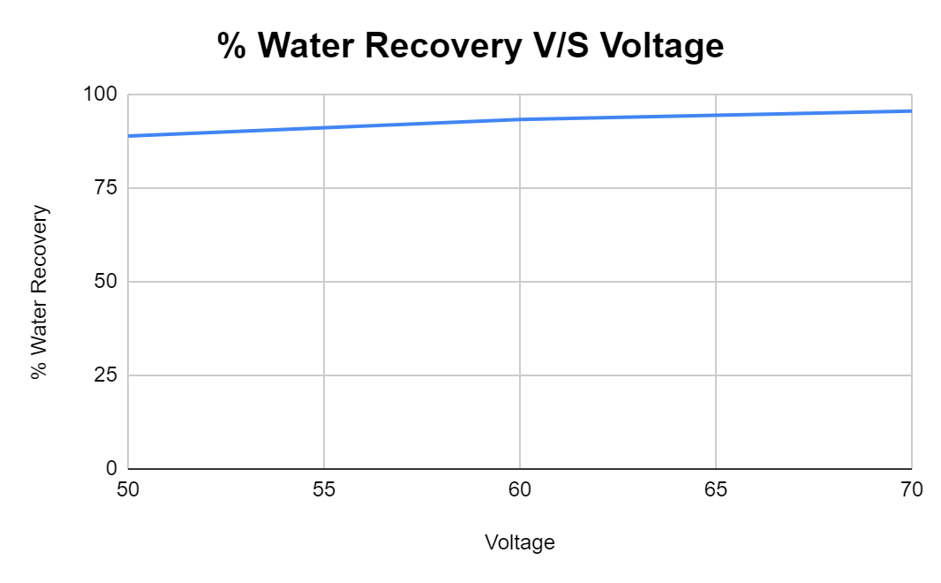

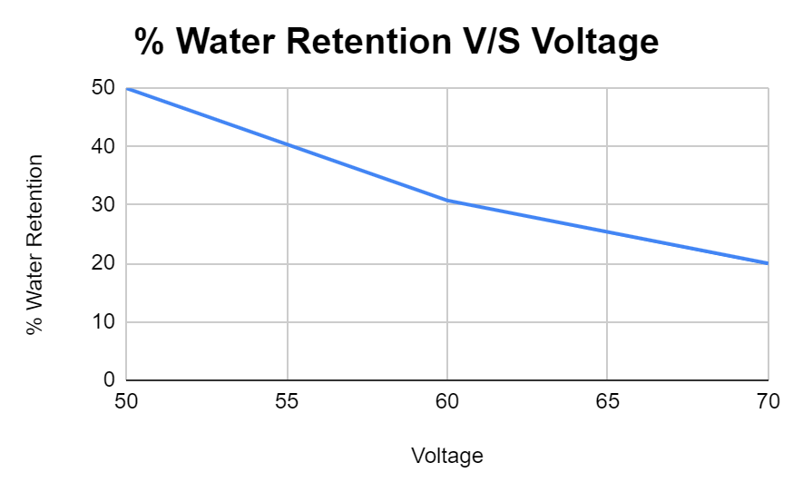

The above two graphs show that with increase in the rotational speed of the basket centrifuge the water recovery increases and percentage retention of water in the cake formed decreases. This is intuitive and agrees with the theory suggesting that with increased rotational speed the basket centrifuge collects the same amount of filtrate at a higher water recovery percentage and lower water retention.

1. ***Conclusion:***

* In basket centrifuge the water recovery increases with increase in rotational speed
* In basket centrifuge the water retention decreases with increase in rotational speed
* Calculating the water retention by calculating the water recovery is a more accurate method as no external operation is not needed to calculate the water recovery thus reducing the error due to efficiency of heater

**Experiment: 4-b)**

**Froth Floatation**

1. ***Aim:***

To study the separation performance of froth floatation using Denver Floatation cell.

1. ***Objective:***

* To calculate the percentage recovery of coal using Denver Floatation Cell.

1. ***Observation and Calculations:***

|  |  | **Coal = 10 g** | |  |  |
| --- | --- | --- | --- | --- | --- |
|  |  | **Sand = 90 g** | |  |  |
|  |  | **Detergent = Fixed = 15ml** | |  |  |
|  |  |  |  |  |  |
| **S. No** | **Pine Oil (ml)** | **Time (min)** | **Weight of filter cloth+Particles (g)** | |  |
| **Dry weight of cloth (g)** | **Dry weight of cloth + coal (g)** | **weight of coal (g)** |
| 1 | 5 | 10 | 29 | 31 | 3 |
| 2 | 10 | 10 | 40 | 44 | 4 |

**Calculations:**

**<math xmlns="http://www.w3.org/1998/Math/MathML"><mo>%</mo><mo>&#xA0;</mo><mi>r</mi><mi>e</mi><mi>c</mi><mi>o</mi><mi>v</mi><mi>e</mi><mi>r</mi><mi>y</mi><mo>&#xA0;</mo><mi>o</mi><mi>f</mi><mo>&#xA0;</mo><mi>c</mi><mi>o</mi><mi>a</mi><mi>l</mi><mo>&#xA0;</mo><mo>=</mo><mo>&#xA0;</mo><mfrac><mrow><mn>100</mn><mo>&#xD7;</mo><msub><mi>W</mi><mn>2</mn></msub></mrow><msub><mi>W</mi><mn>1</mn></msub></mfrac><mspace linebreak="newline"/><mi>w</mi><mi>h</mi><mi>e</mi><mi>r</mi><mi>e</mi><mo>:</mo><mspace linebreak="newline"/><msub><mi>W</mi><mn>1</mn></msub><mo>&#xA0;</mo><mi>i</mi><mi>s</mi><mo>&#xA0;</mo><mi>i</mi><mi>n</mi><mi>i</mi><mi>t</mi><mi>i</mi><mi>a</mi><mi>l</mi><mo>&#xA0;</mo><mi>w</mi><mi>e</mi><mi>i</mi><mi>g</mi><mi>h</mi><mi>t</mi><mo>&#xA0;</mo><mi>o</mi><mi>f</mi><mo>&#xA0;</mo><mi>c</mi><mi>o</mi><mi>a</mi><mi>l</mi><mspace linebreak="newline"/><msub><mi>W</mi><mn>2</mn></msub><mo>&#xA0;</mo><mi>i</mi><mi>s</mi><mo>&#xA0;</mo><mi>f</mi><mi>i</mi><mi>n</mi><mi>a</mi><mi>l</mi><mo>&#xA0;</mo><mi>w</mi><mi>e</mi><mi>i</mi><mi>g</mi><mi>h</mi><mi>t</mi><mo>&#xA0;</mo><mi>o</mi><mi>f</mi><mo>&#xA0;</mo><mi>c</mi><mi>o</mi><mi>a</mi><mi>l</mi><mspace linebreak="newline"/><mi>G</mi><mi>i</mi><mi>v</mi><mi>e</mi><mi>n</mi><mo>:</mo><mspace linebreak="newline"/><msub><mi>W</mi><mn>1</mn></msub><mo>&#xA0;</mo><mo>=</mo><mo>&#xA0;</mo><mn>10</mn><mo>&#xA0;</mo><mi>g</mi><mi>r</mi><mi>a</mi><mi>m</mi><mspace linebreak="newline"/><msub><mi>W</mi><mn>2</mn></msub><mo>&#xA0;</mo><mo>=</mo><mo>&#xA0;</mo><mn>4</mn><mo>&#xA0;</mo><mi>g</mi><mi>r</mi><mi>a</mi><mi>m</mi><mspace linebreak="newline"/><mo>%</mo><mo>&#xA0;</mo><mi>r</mi><mi>e</mi><mi>c</mi><mi>o</mi><mi>v</mi><mi>e</mi><mi>r</mi><mi>y</mi><mo>&#xA0;</mo><mi>o</mi><mi>f</mi><mo>&#xA0;</mo><mi>c</mi><mi>o</mi><mi>a</mi><mi>l</mi><mo>&#xA0;</mo><mo>=</mo><mo>&#xA0;</mo><mfrac><mrow><mn>100</mn><mo>&#xD7;</mo><mn>4</mn></mrow><mn>10</mn></mfrac><mspace linebreak="newline"/><mo>%</mo><mo>&#xA0;</mo><mi>r</mi><mi>e</mi><mi>c</mi><mi>o</mi><mi>v</mi><mi>e</mi><mi>r</mi><mi>y</mi><mo>&#xA0;</mo><mi>o</mi><mi>f</mi><mo>&#xA0;</mo><mi>c</mi><mi>o</mi><mi>a</mi><mi>l</mi><mo>&#xA0;</mo><mo>=</mo><mo>&#xA0;</mo><mn>40</mn><mo>%</mo></math>**

1. ***Results and Discussions:***

| **S.No.** | **Final wt. Of Coal(gram)** | **% recovery of coal** |
| --- | --- | --- |
| **1.** | 3 | 30 |
| **2.** | 4 | 40 |

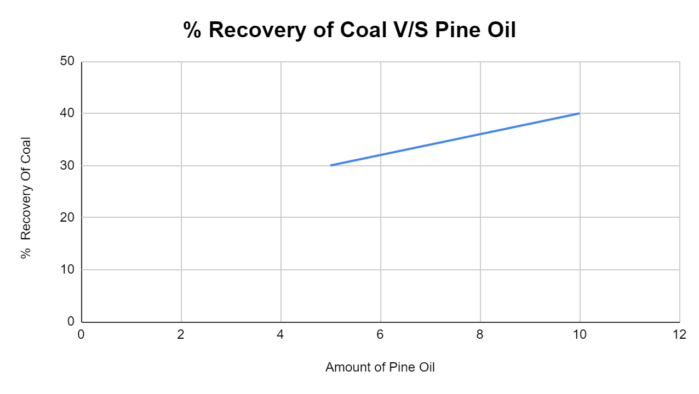

The experiment was carried out for constant collection time and varying concentration of pine oil. The above graph depicts that with increase in pine concentration the recovery increases. This might be because pine oil acts like a collector and promoter. Thus increasing the concentration of pine increases the coal carrying capacity of the air avid and water repellent particles.

1. ***Conclusion:***

* The Denver flotation cell is used to recover coal particles from a mixture of coal and sand particles.
* The recovery increases with increase in pine oil concentration in the floatation cell as the carrying capacity increases